Linking folders to display image collections – User manual
In view of our customers' request, to allow the connection of folders (all files or selected ones), as well as the option to link one item's folder to another item, there is a new Digital Asset type called "Folder" [FOLDER]. Several changes were made in the Digital Assets' interface:
Digital Asset Classification – You can define whether it is a 'regular' type or a File link.
Activation- There is an additional option for selection: "calculated". When choosing this option you can define for each environment (Windows / Internet / Intranet) a calculated command line - to activate the file, by creating a calculated expression. If the Digital Asset classification is defined as a Folder Link, there will be an option to display the folder using the built-in folder viewer.
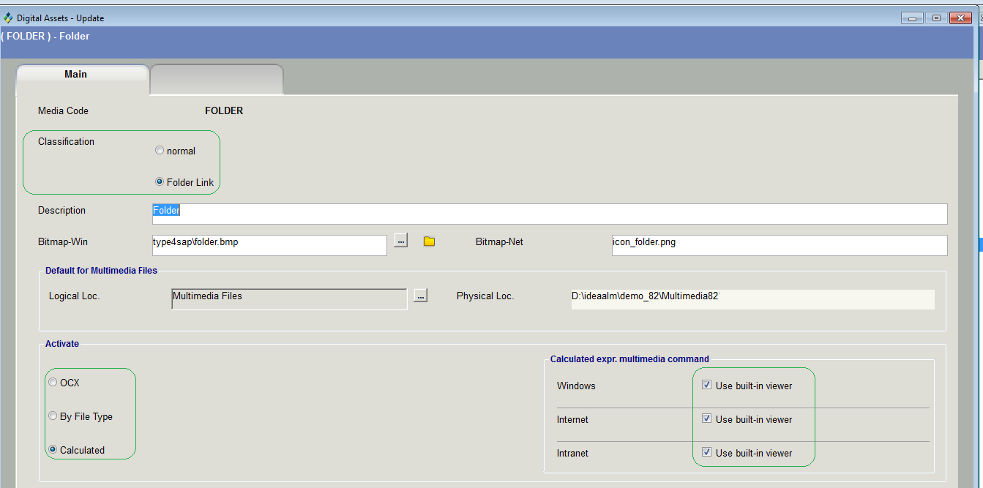
See the screenshot above - an example of a Digital Asset classified as a calculated Folder Link, where in the Windows and in Internet environment it will be displayed using the built-in Viewer, and in the Internet environment will be displayed using a calculated command line.
Collecting fields: "Folder Link" and "Pointer to Digital Object"
The Folder Link (FOLDCOL) contains the following fields:
Digital Object Type - a table-type field displaying the 'Digital Assets' table. The system allows selection of Folder types only.
Folder Name – The name of the folder whose contents we want to display. The opening window will present all the sub-folders under the folder that was defined in the physical location
File Location – The same as in linking 'regular' multimedia files.
Range Begin – When selecting files within a specific range in the folder – here you select the first one
Range End – The last file of the selected range.
Note: You can type the file name of the first one at the beginning of the range, and the file name of the one at the end of the range, even if you have not saved all the files yet. In this case new files that will be added within the defined range will be displayed too.
Object List- for linking selected images in the folder for display
Note: If no images were selected and the range fields are empty - all the images of the folder will be displayed.
* If only the beginning or the end of the range is filled in - the images will be displayed from the beginning of the range to the folder's end or from the beginning of the folder to the end of the range, respectively.
* There is also a possibility to fill in both the list and the range. In this case their combination will be displayed.
Display on Web - An indicator for display on the web
Display on Intranet - An indicator for display on the intranet
Pointer to Digital Object [MULPTRCOL] contains the following collected fields:
Parent Item –Link to the "parent" item whose digital assets will be displayed in the current one
Pointer to mul.ID - Unique identifier for the pointed multimedia link (for display only, non-editable)
Range Begin – When selecting files within a specific range in the folder – here you select the first one
Range End – The last file of the selected range.
Note: You can type the file name of the first one at the beginning of the range, and the file name of the one at the end of the range, even if you have not saved all the files yet. In this case new files that will be added within the defined range will be displayed too.
Object List- for linking selected images in the folder for display.
Note: This field is relevant only when using the built-in folder Viewer
Note: If no images were selected and the range fields are empty - all the images of the folder will be displayed.
* If only the beginning or the end of the range is filled in - the images will be displayed from the beginning of the range to the folder's end or from the beginning of the folder to the end of the range, respectively.
* There is also a possibility to fill in both the list and the range. In this case their combination will be displayed.
Display on Web - An indicator for display on the web
Display on Intranet - An indicator for display on the intranet

NOTE: the built-in Files Viewer displays only image files.

Linking folders to items

1. Folder link
a. Add the new Digital Asset type "FOLDER" to the relevant template:
Administration > Templates > select the template for edition > Tab 'Input fields' > Sub-Tab 'Digital Assets' > click 'Insert Row' icon and select "Folder Link"
b. Open the item > 'Dig. Assets' Tab and click the + next to the 'Folder Link'
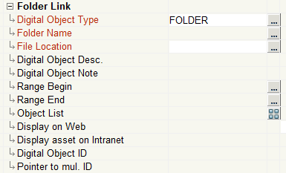
c. Open the 'Digital Object Type' table and select the 'Folder'
Click the table icon next to the Folder Name and select the relevant file (you may enter the name of it manually but it is advisable to choose it in the window (see below)
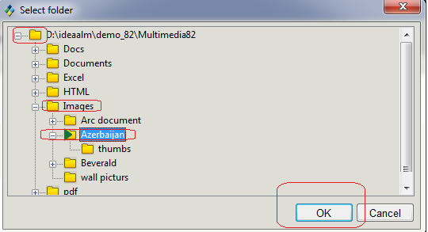
*The root folder is the one defined in the 'File Location' field. Mark the desired folder by navigating (double click) and click 'OK'
*File Location is filled automatically upon selecting the Digit. Asset's type but can be altered
* 'Range Begin' and 'Range End' are optional: define the range of files for display by choosing the first and last files. You may type their names but it is advisable to do it in the selection window.

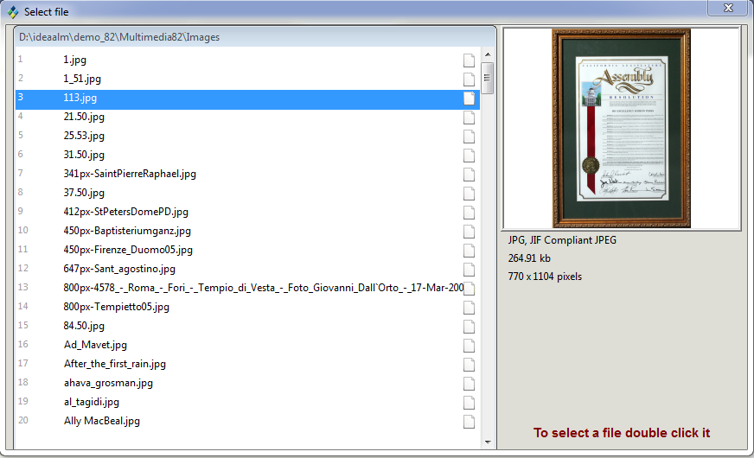
You may choose one file only, for the beginning/end of the range.
*Object List is also optional – when you want to choose several selected files for display. This can only be done in the selection window clicking the icon. In the window list mark the chosen files for display clicking the checkboxes next to them.
* By using the check boxes (on the left side of the file names) you can select one or more files. If the files have already been selected in this way before, they will be marked at the top of the list. If at least one file is selected, the field 'Object List' will get the value "Y"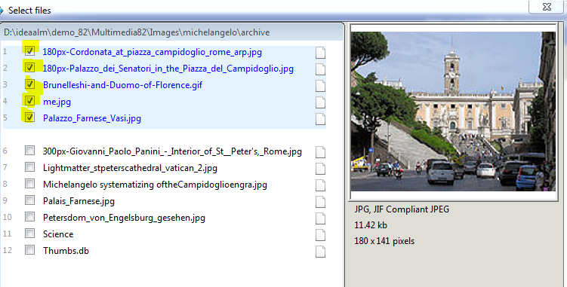

2. Pointer to Digital Object
a. Add the new Digital Asset type 'Pointer to Digital Object' to the relevant template:
Administration > Templates > select the template for edition > Tab 'Input fields' > Sub-Tab 'Digital Assets' > click 'Insert Row' icon and select 'Pointer to Digital Object'
b. Open the item > 'Dig. Assets' Tab and click the + next to the 'Pointer to Digital Object'. 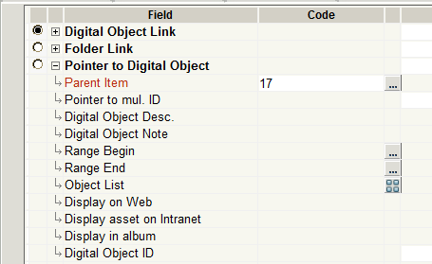
c. In the 'Parent Item' field select the item whose link you want to attach to this item
d. If you want to link only one image from the 'parent item' – mark it (on the right side). If you want to link the whole folder or several images from it – click the 'Object list' squer and select the files for display.
Note: you cannot choose to link a pointer to another pointer.
e. 'Range Begin' and 'Range End' are optional: define the range of files for display by choosing the first and last files. You may type their names but it is advisable to do it in the selection window.
f. 'Range Begin/End' and 'Object List' relevant only when choosing link to a folder
g. Display on Web / on Intranet/Description/note is the same as in any other type.

